|  |  |  |
| --- | --- | --- |
| Course # | Your Name | Lab Assignment Title |
| 01 | **9/22/2022 - Group D**  **Beckley, Aaron**  **Bixby, Elijah**  **Monroe, Tucker**  **Rioux, Andrew** | **Semester Week 4 Lab 1** |

**Lab1: Intro to Cypherpath SDI**

**Goals**

* Complete Lab 1

**Objectives**

* Create Two Kali Boxes
* Create One Network Switch
* Create Two Secure Business LANs

**Purpose**

* Enhance our Networking Skills
* Learn How to Implement Infrastructure
* Have Fun

**Abstract**

Lab 1 wants us to create enough network infrastructure for a network switch and two Kali Linux clients. The lab wants us to do this for two secure business office LANs so we would need to have two identical LANs.

**Introduction**

In this lab we are required to create enough infrastructure for two Kali boxes to be able to communicate with each other. To demonstrate this communication, we must show that the two machines are able to ping each other. The devices needed for this in Cypherpath are two kali virtual machines, and a single network switch. The switch itself is a 10/100/1000mb switch (1000TX network), and we will be using virtual ethernet technology for the network. Because we will use the same switch for any networks we create, all the networks can be assumed to be 1000TX at this time.

The two Kali boxes can be connected to the switch by dragging and dropping them on top of the switch in the GUI. At this point a successful virtual network will be created because the switch itself provides DHCP. As stated previously, one of our purposes is to have fun. Therefore, we immediately disabled that. This is due to the lack of fun with the machine picking the addresses. At this point we defined our network as having two nodes, the kali boxes, having the IP addresses 10.10.10.10 and 10.10.10.11. We decided to use the netmask 255.192.0.0 which translates to /10 for that extra flare.

**Method**

Steps to reproduce:

1. Log into Cypherpath
2. Create a blank environment
3. Create network switch
4. Edit network switch so it no longer provides DHCP, but keep VLAN
5. Add two kali boxes
6. Drag kali boxes on top of network switch to connect them
7. Log into the kali boxes
8. Setup static IP addresses for both kali boxes
9. Ip address 10.10.10.10 for one and 10.10.10.11 for the other
10. We used the netmask 255.192.0.0
11. Command is “ip a add (IP OF KALI)/10 brd + dev eth1”
12. To enable persistence, we went into the NetworkManager UI on each of the Kali boxes and modified the interface settings for each network interface to match the IP command results
13. After this you will be able to ping both Kali boxes

**Results**

Two LANs were configured. Each LAN contained one switch and two machines. Each machine on each switch demonstrated the commands “ping” and “tcpdump” to display the functionality of the finished project. The figures below demonstrate the final state in addition to proving that the machines work to fulfill the program requirements. We also used SSH to remote login to both machines. This confirmed that they were able to communicate with each other.

**Figure 1**

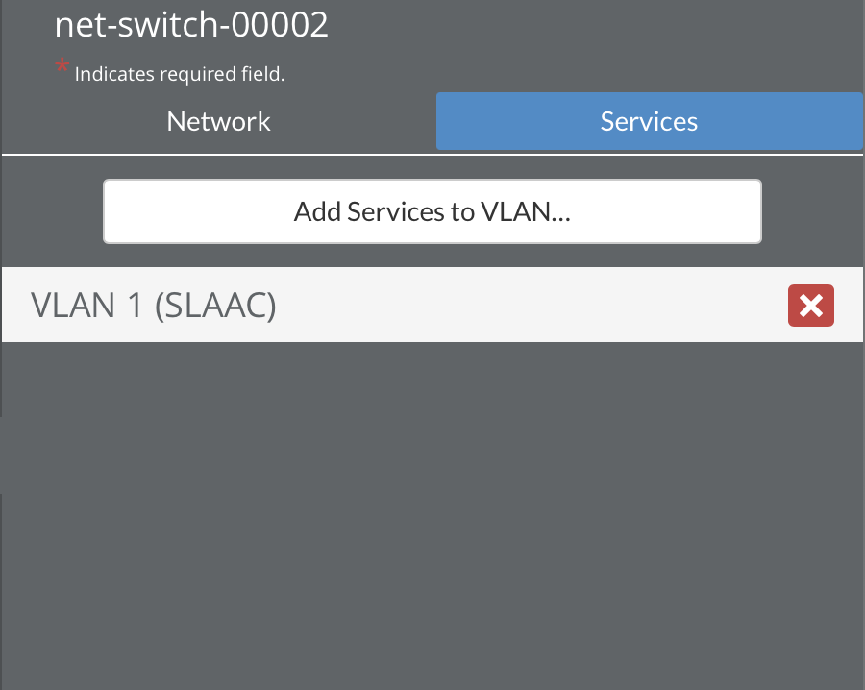

*Note. Display of VLAN1 on network switch*

**Figure 2**

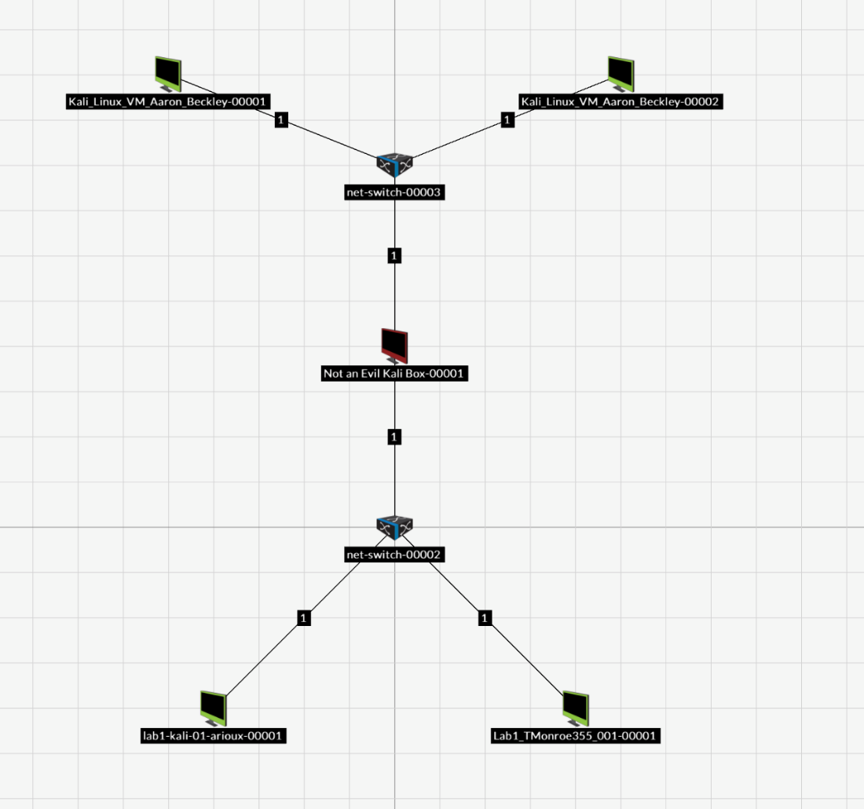

*Note. Infrastructure of the networks using switches attached to machines each*

**Figure 3**

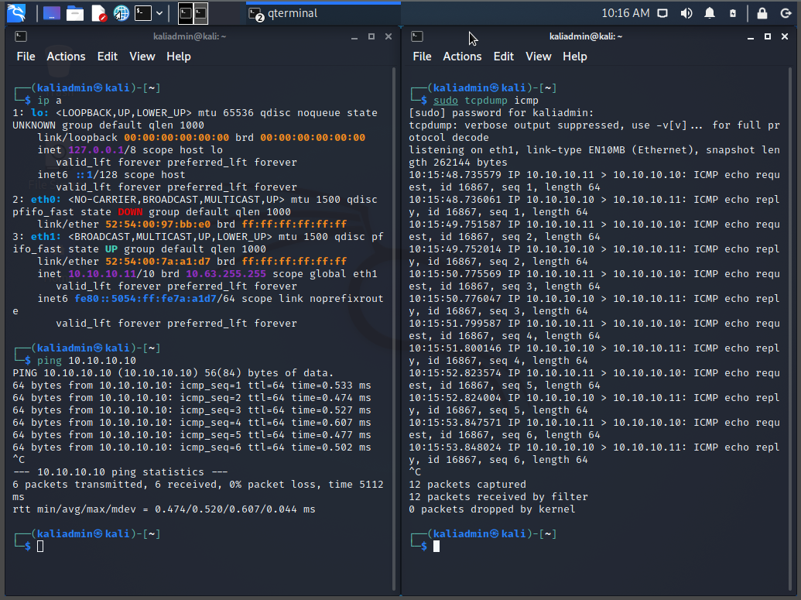

*Note. One machine is pinging the other and using* *tcpdump to record the pinging*

**Figure 4**

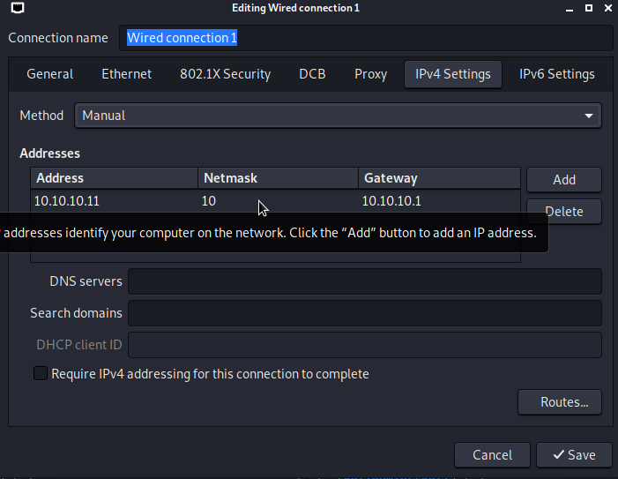

*Note. The persistent configuration for the Kali boxes, in this case for box 2*

**Figure 5**

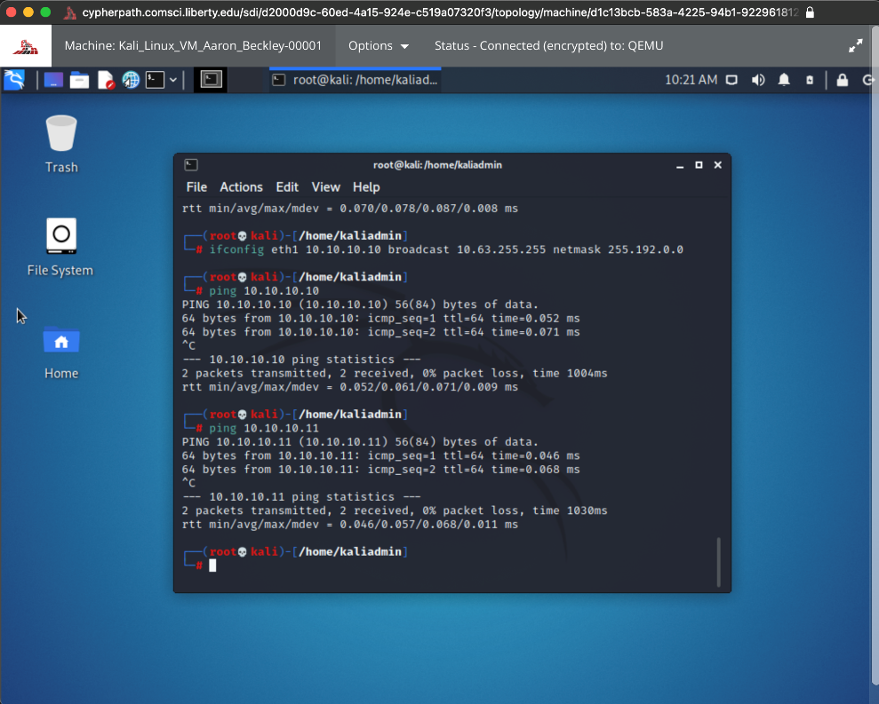

*Note. The demonstration of working ifconfig to set static IP*

**Figure 6**

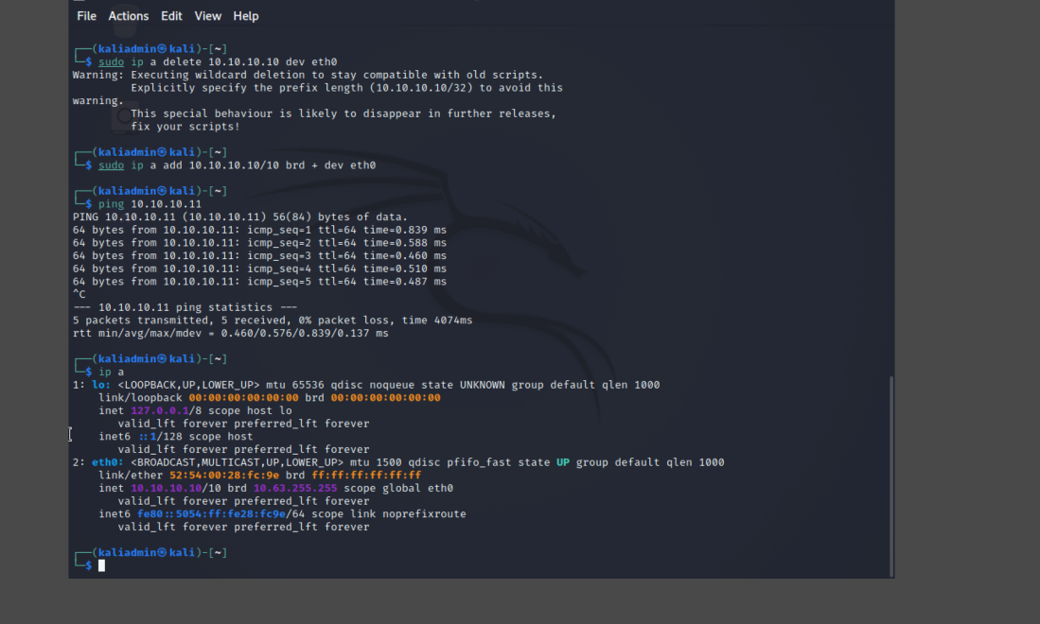

*Note. The demonstration of the ip command to set static IP*

**Figure 7**

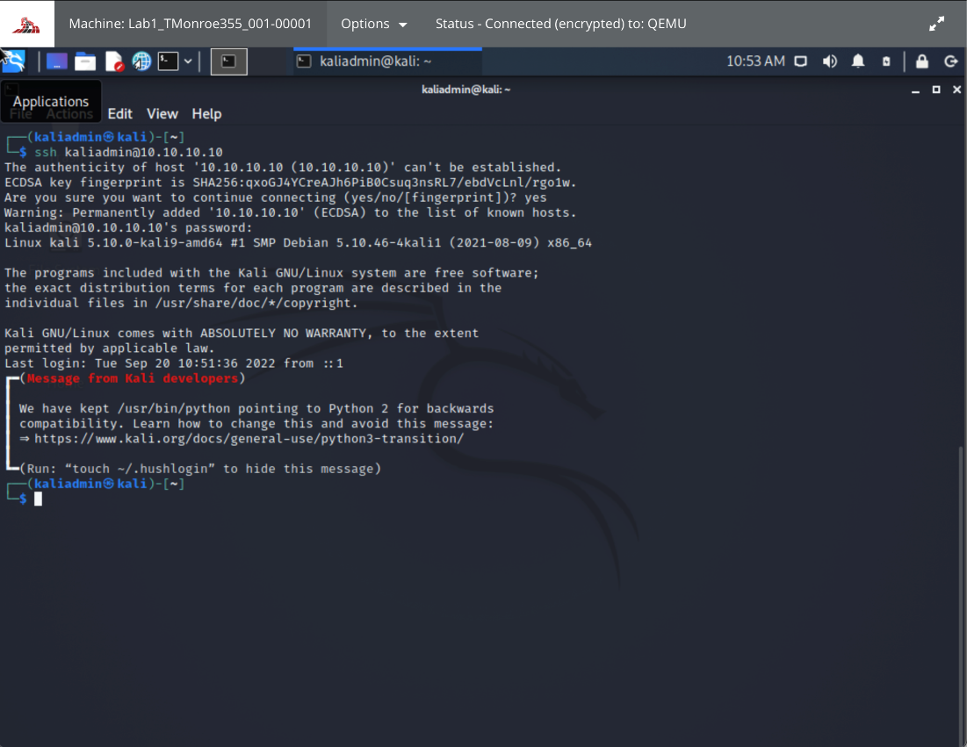

*Note. Example of SSH working*

**Discussion**

In this lab we configured two different LANs each with the same principles. Each had two kali boxes. Each had one switch. When we first started setting it up, we tried using ifconfig 10.10.10.10 netmask 255.192.0.0, but this did not work. We found out we had more success with the ip command. We found that we needed to specify the broadcast for it to work. We also found that to disable DHCP on the switch we must keep the VLAN and just click the disable DHCP button. We kept SLAAC because we did not care about IPV6. We tested SSH between the boxes. We found that the kali boxes do not have a firewall. This is a security risk worth investigating. We had to enable the ssh server by using systemctl enable sshd.

**Conclusion**

On this lab we learned: how to use Cypherpath, how to set up two kali boxes on a network, how to set up a switch, and teamwork. We learned how to set up the two kali boxes by setting them up on Cypherpath, and we learned how to configure the switch by disabling its DHCP. The team then assigned static IP addresses to both machines to give an added level precision when each computer pings the other machine.